Software Design Document
Web-Based Complaint Monitoring System



Submitted by:
Muhammad Jabran Majeed (F22BINFT1E02073)
Submitted to:
Dr. Musarat Karim

Department of Information Technology
Faculty of Computing
The Islamia University of Bahawalpur

Summary
This Software Design Document (SDD) provides a complete and detailed design of the Web-Based Complaint Monitoring System, prepared strictly according to the approved Software Requirements Specification (SRS) and the provided SDD Template.
This document explains the system architecture, design considerations, MVC pattern, backend and frontend structure, database schema, APIs, UML diagrams, and user interface design.
The system aims to improve transparency, accountability, and efficiency in complaint handling for universities and organizations.

Table of Content
- Application Architecture
- Design Considerations
- Architectural Pattern (MVC)
- Backend Design (Flask)
- Frontend Design (HTML/CSS)
- API Design
- Data Model Schema
- UML Diagrams
- User Interface Design
- Coding Standards

- Application Architecture
The Web-Based Complaint Monitoring System follows a three-tier architecture:
Presentation Layer: HTML, CSS, Bootstrap
Application Layer: Python (Flask Framework)
Data Layer: MySQL Database
This architecture ensures modularity, scalability, security, and easy maintenance.

System Architecture Diagram:

(Figure 01)

2. Design Considerations
The system design is based on the following considerations derived from the SRS:
Secure authentication and authorization
Simple and user-friendly interface
Fast response time (under 2 seconds)
Reliable database consistency
Clear separation between user and admin roles

3. Architectural Pattern – MVC
The system uses the Model-View-Controller (MVC) pattern.
MVC Components
Model
Handles database interaction
Represents system entities (User, Complaint, AdminNotes)
View
HTML pages displayed to users
Shows data received from controllers
Controller
Flask routes
Processes user requests
Applies business logic
Connects View and Model

MVC Flow Diagram:

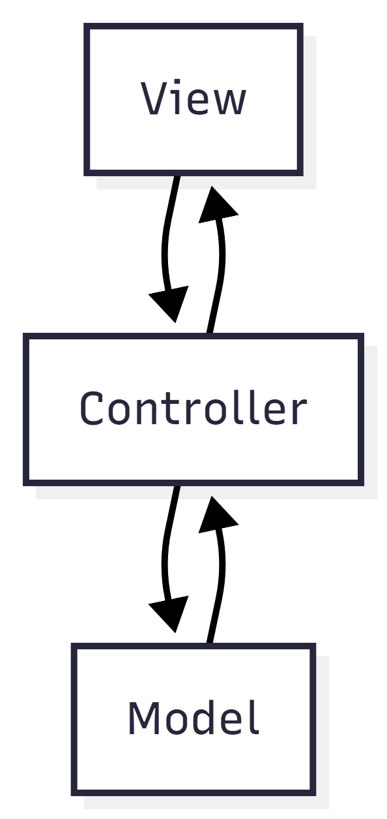
(Figure 02)

4. Backend Design (Flask)
The backend is developed using Flask (Python).
Controllers & Functions
AuthController
register_user()
login_user()
logout_user()
ComplaintController
submit_complaint()
view_user_complaints()
get_complaint_status()
AdminController
view_all_complaints()
update_complaint_status()
delete_complaint()
add_internal_notes()

5. Frontend Design (HTML/CSS)
Design Philosophy
Clean and minimal UI
Responsive design using Bootstrap
Easy navigation for users and admin
Pages List
Home Page
User Registration Page
Login Page
User Dashboard
Submit Complaint Page
View Complaint Status Page
Admin Dashboard
Manage Complaints Page
Input Constraints
Required field validation
Email format validation
Password minimum length: 8 characters

6. API Design
HTTP Method | Endpoint | Description
POST | register | Register a new user
POST | login | Authenticate user
POST | complaint | Submit complaint
GET | complaints | View user complaints
PUT | admin/complaint | Update complaint status

7. Data Model Schema
The database of the Web-Based Complaint Monitoring System is designed using MySQL and follows a relational database model.
The design ensures data consistency, integrity, and efficient retrieval of information.
The database supports user management, complaint handling, and administrative tracking.
The system consists of the following main entities:
7.1 User Entity
The User entity stores information about all registered users of the system, including students, employees, and administrators.
Attributes:
user_id (Primary Key): Unique identifier for each user
name: Full name of the user
email: Email address used for login
password: Encrypted password for authentication
department: Department to which the user belongs
role: Defines whether the user is a normal user or an admin
Description:
Each user must register and log in to access the system. The role attribute helps distinguish between normal users and administrators, enabling role-based access control.
7.2 Complaint Entity
The Complaint entity stores all complaints submitted by users.
Attributes:
complaint_id (Primary Key): Unique identifier for each complaint
user_id (Foreign Key): References the user who submitted the complaint
title: Short title of the complaint
description: Detailed explanation of the complaint
category: Complaint category (e.g., Academic, Admin, Facility)
status: Current status (Pending / In-Process / Resolved / Rejected)
created_at: Date and time when the complaint was submitted

Description:
A user can submit multiple complaints, but each complaint belongs to only one user.
The status field allows users and admins to track the progress of complaints.
7.3 AdminNotes Entity
The AdminNotes entity stores internal notes added by administrators regarding complaints.
Attributes:
note_id (Primary Key): Unique identifier for each note
complaint_id (Foreign Key): References the related complaint
note: Description or comment added by the admin
timestamp: Date and time when the note was added
Description:
Each complaint can have multiple admin notes. These notes are used internally by administrators to document actions, decisions, or progress related to complaint resolution.
7.4 Entity Relationships
One User can submit multiple Complaints (One-to-Many relationship).
Each Complaint is submitted by exactly one User.
One Complaint can have multiple AdminNotes (One-to-Many relationship).
Each AdminNote belongs to exactly one Complaint.
This relational design ensures efficient complaint tracking, clear accountability, and proper data normalization.
7.5 ER Diagram
The relationships between entities are illustrated using an Entity Relationship (ER) Diagram, which visually represents how users, complaints, and admin notes are connected within the system.

ER Diagram:
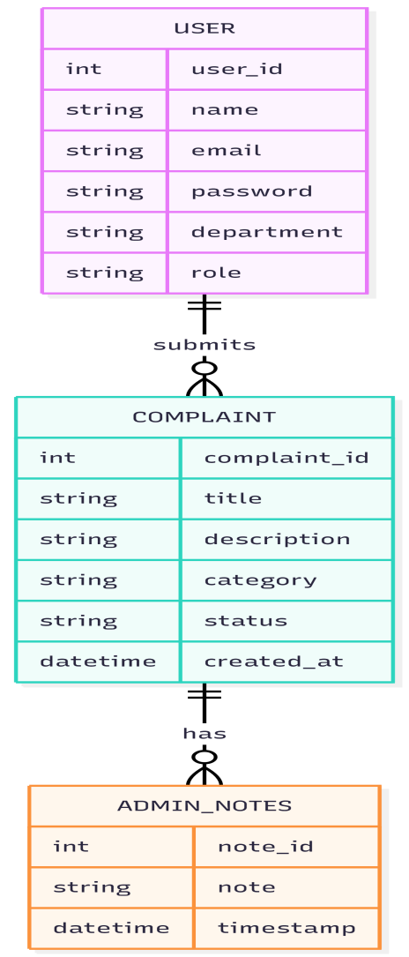
(Figure 03)

8. UML Diagrams
Use Case Diagram:
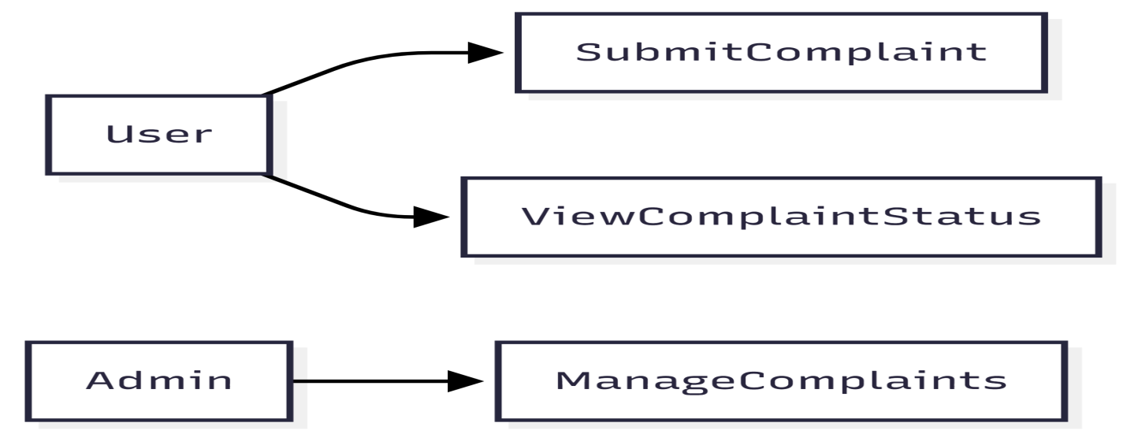
(Figure 04)

Sequence Diagram – Submit Complaint (UC001

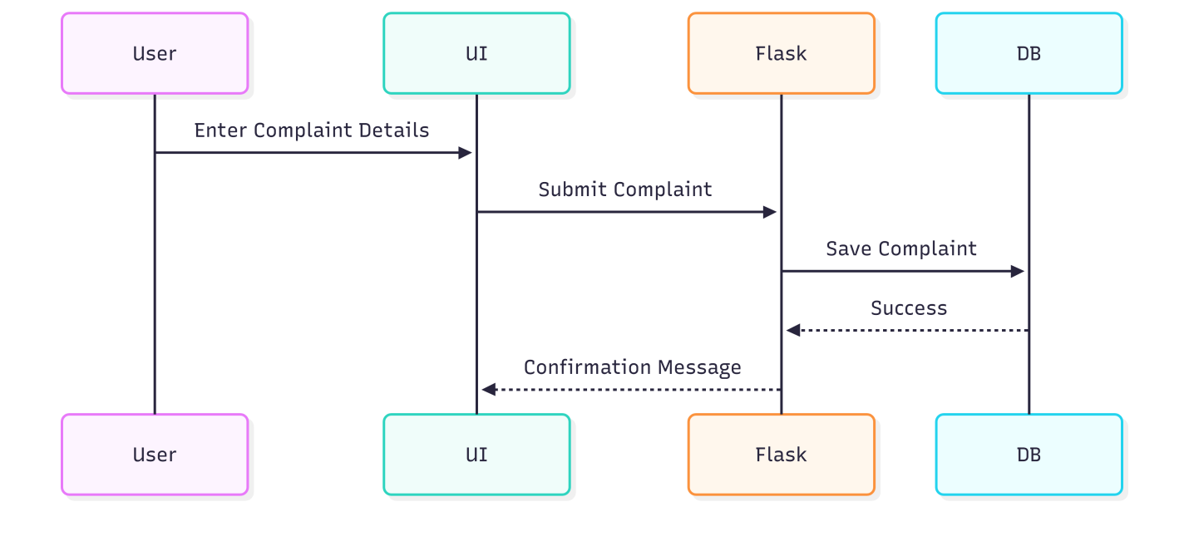
(Figure 05)

Sequence Diagram – View Complaint Status (UC002)

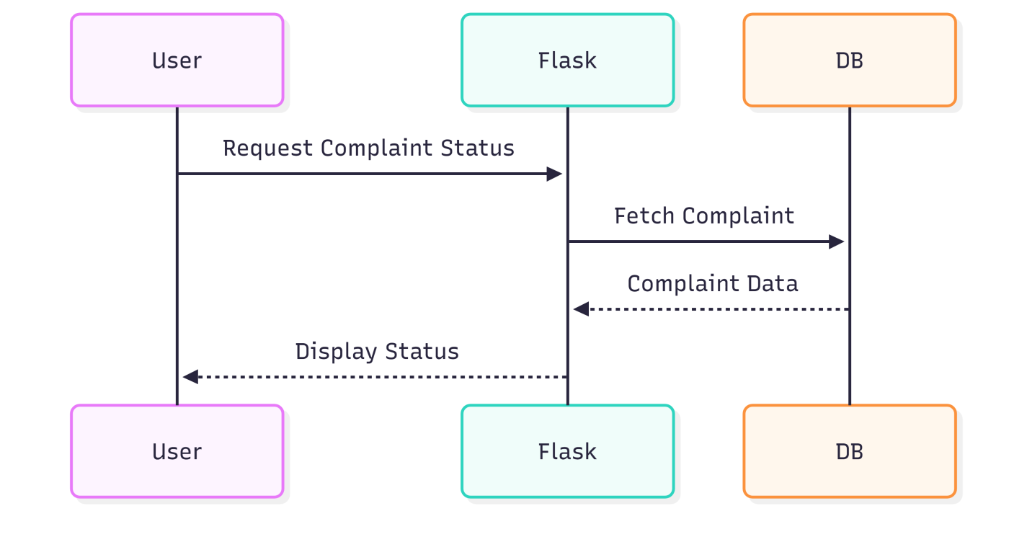
(Figure 06)

9. User Interface Design
User Dashboard
Submitted complaints list
Status indicators (Pending / In-Process / Resolved)
Submit complaint option
Admin Dashboard
All complaints list
Filter by status
Update / resolve / delete complaints
UI Controls
Textboxes
Dropdown menus
Buttons
Tables
10. Coding Standards & Conventions
Python PEP-8 followed
Meaningful variable and function names
Modular Flask structure
Secure password encryption
Proper error handling

